
Engineering for everyday world

AceEngineer

PROJECT WEB REPORT

Development Manual

14th September 2016

9-Sep-2016 | 01 | New Issue |  |  |  |  | VA | - | -
DATE | REV | DESCRIPTION |  |  |  |  | ORIG | CHK | APPR
DOCUMENT CONTROL NO |  | Project | Type | Area | Client | - | - | Sequence | Revision
 |  | - | - | - | - | - | - | - | 01

Revision History:

REV | DATE | DESCRIPTION | ORIG | CHK | APPR
01 | 9th Dec 2014 | Manual for project web report | MP | VA | VA

Change Log

REV | SECTION | CHANGE DESCRIPTION
Document Holds
Hold | DESCRIPTION

CONTENTS
1 Introduction 4
2 Summary 4
3 Headings 5
3.1 Sidebar Navigation 6
3.1.1 Introduction 6
3.1.2 Chart 7
4 Text 8
5 Tables 9
6 Picture 10
7 Charts 11
8 References 15

Introduction
Engineering projects always requires adequate reporting so as to help clients assimilate project findings. Reports can also help in following:
- A requirement for the engineering teams so as to maintain the project assumptions and results in place
- Avoid costly assumptions and misunderstandings from client.

Summary

Description | HTML Code | Detailed Section
Title | <title>  </title>
Report Title | <h1>  </h1>
Heading 1 | <h2>  </h2> | 3
Heading 2 | <h3>  </h3>
Text Body | <p>  </p>
Table 2.1 – Main Report

Description | HTML Code | Detailed Section
Table Row | <tr>  </tr>
Table Header | <th>  </th>
Table Data | <td>  </td>
Text Body | <p>  </p>
Table 2.2 – Table

Description | HTML Code | Detailed Section
Navigation Bar Section Label | <div id="sectionLabel">  </div> | 3.1
Navigation Bar Hyperlink | <li onClick="scrollToDiv(' sectionLabel')"> 4.1 Section Number and Label</li>
Table 2.3 – Navigation Bar

Description | HTML Code | Detailed Section
Section division and Section Label | <div id="sectionLabel">  </div>
Navigation Bar Hyperlink | <li onClick="scrollToDiv(' sectionLabel')"> 4.1 Section Number and Label</li>
Table 2.4 – Charts

Headings

For heading in CSS we should use this code.

<h2>Web Report</h2>
Where: <h2> indicates the header.

Sidebar Navigation
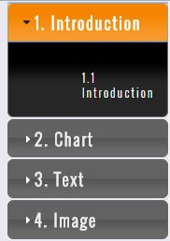

Introduction
<div id="sidenav">

<h3>1. Introduction</h3>
<div>

<ul>

<li onClick="scrollToDiv('#introduction')">1.1 Introduction</li>

</ul>

</div>

Chart
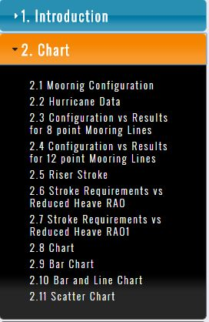

In side navigation bar to get chart and sub division charts the below code is helpful.

<h3>2. Chart</h3>
<div>
<ul>

<li onClick="scrollToDiv('#mooringcongfiguration1')">2.1 Moornig Configuration</li>
<li onClick="scrollToDiv('#hurricanedata1')">2.2 Hurricane Data</li>
<li onClick="scrollToDiv('#configurationvsresultsfor8pointmooringlines1')">2.3 Configuration vs Results for 8 point Mooring Lines</li>
<li onClick="scrollToDiv('#configurationvsresultsfor12pointmooringlines1')">2.4 Configuration vs Results for 12 point Mooring Lines</li>
<li onClick="scrollToDiv('#riserstroke1')">2.5 Riser Stroke</li>
<li onClick="scrollToDiv('#strokerequirementsvsreducedheaverao1')">2.6 Stroke Requirements vs Reduced Heave RAO</li>
<li onClick="scrollToDiv('#strokerequirementsvsreducedheaverao11')">2.7 Stroke Requirements vs Reduced Heave RAO1</li>
<li onClick="scrollToDiv('#linechart1')">2.8 Chart</li>
<li onClick="scrollToDiv('#barchart1')">2.9 Bar Chart</li>
<li onClick="scrollToDiv('#barandlinechart1')"> 2.10 Bar and Line Chart</li> <li onClick="scrollToDiv('#scatterchart1')"> 2.11 Scatter Chart</li>
</ul>

</div>

Text
The text-align property is used to set the horizontal alignment of a text.

A text can be left or right aligned, centred, or justified.

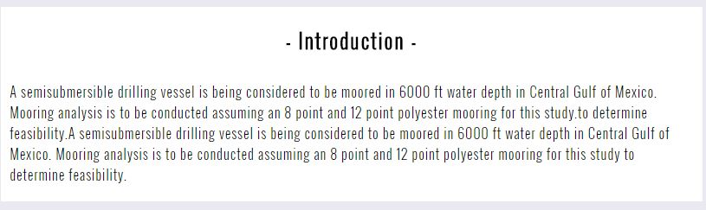

For writing the text in the CSS code in below

<div id="introduction">

<h2>- Introduction -</h2>
<p>A semisubmersible drilling vessel is being considered to be moored in 6000 ft water depth in Central Gulf of Mexico. Mooring analysis is to be conducted assuming an 8 point and 12 point polyester mooring for this study.to determine feasibility.A semisubmersible drilling vessel is being considered to be moored in 6000 ft water depth in Central Gulf of Mexico. Mooring analysis is to be conducted assuming an 8 point and 12 point polyester mooring for this study to determine feasibility.</p>

</div>
Where: <div> it will separate the heading from one heading to other.
<p> it will indicates the paragraph under <h2>.

Tables
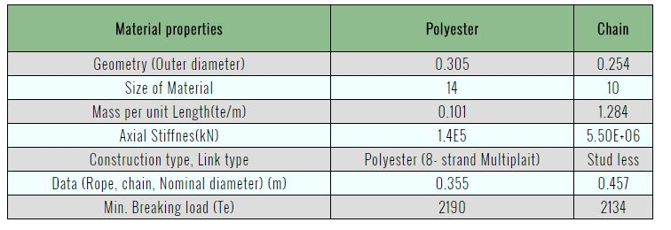
To keep the table in css we used the <th> and <td>, <tr> elements,
Where: <th> is used for headings in the table.
<td> is used for sub topics in the table.
<tr> is used to separate the rows and columns in the table.
The example code for the above table is in below.
<tr>

<th>Material properties</th>
<th>Polyester</th>
<th>Chain</th>

</tr>

<tr>

<td>Geometry (Outer diameter)</td>
<td>0.305</td>
<td>0.254</td>
</tr>

To change the colour in the table the following code is used in the CSS

tr:nth-child(odd) {
text-align:center;
background-color: #F0FFFF
}

tr:nth-child(even) {
text-align:center;
background-color: #dddddd;
}

Picture

For keeping the picture by using the CSS the following code is used.

</div>
<div class="picture_container" id="picture1">
<h3>Picture</h3>
<img src="pictures/computer.jpg"
</div>

PICTURE CSS :Code
.picture_container {

width: 60%;
float: right;
margin-right: 19%;
margin-top: 10px;
background-color: #ffffff;
height: 500px;

}
.picture_container h3 {

font-family: 'Oswald', monospace;
letter-spacing: 2px;
text-align: center;

}

.picture_container img {

display: block;
margin-left: auto;
margin-right: auto;
width: 400px;

}

.picture_container p i{

font-size: 12px;
margin-top: 0;

}

Charts
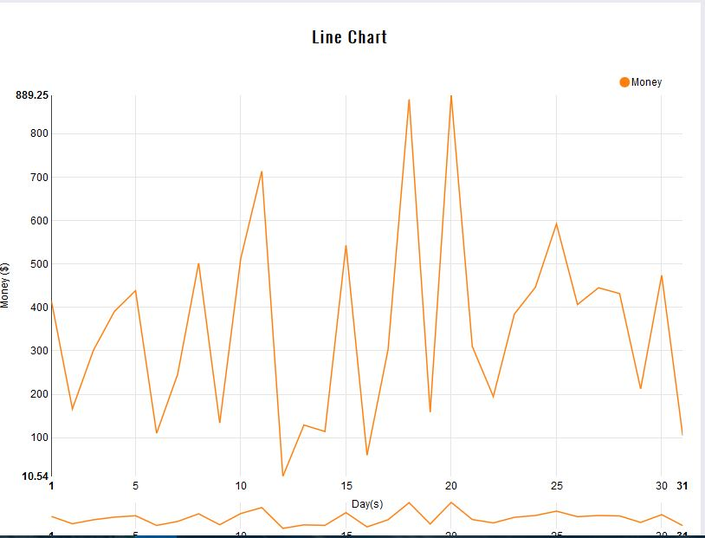
Figure 1 Line Char
<div class="chart_container" id="linechart1">

<h3>Line Chart</h3>

<svg></svg>

</div>

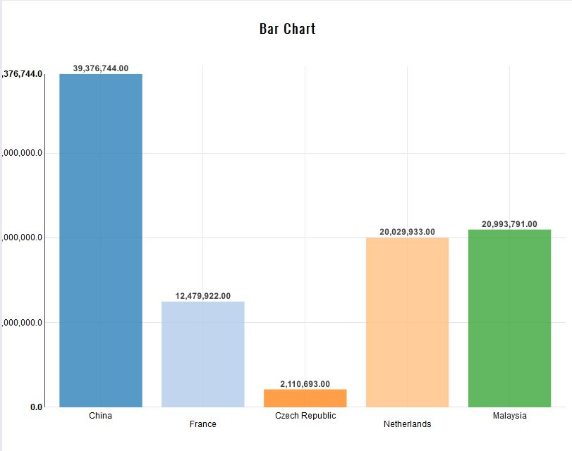
Figure 2 Barchart
<div class="chart_container" id="barchart1">

<h3>Bar Chart</h3>
<svg></svg>
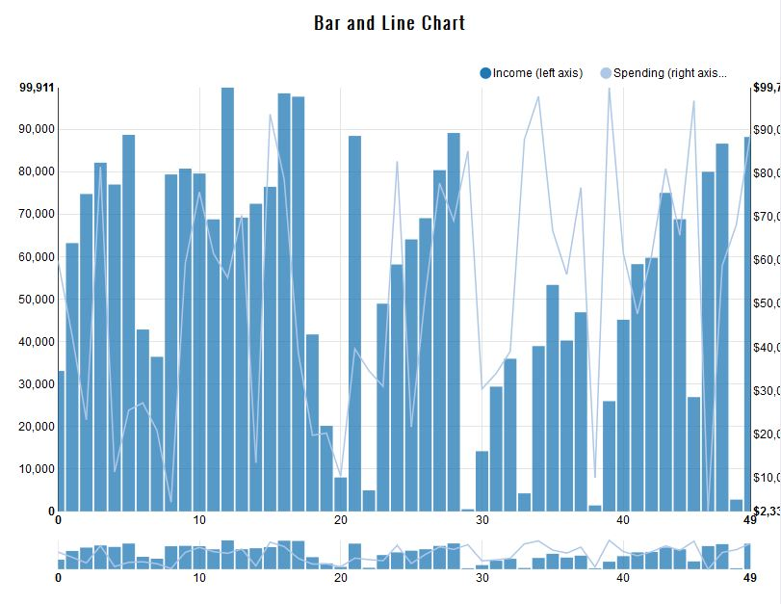
Figure 3

</div>

<div class="chart_container" id="barandlinechart1">

<h3>Bar and Line Chart</h3>
<svg></svg>

</div>
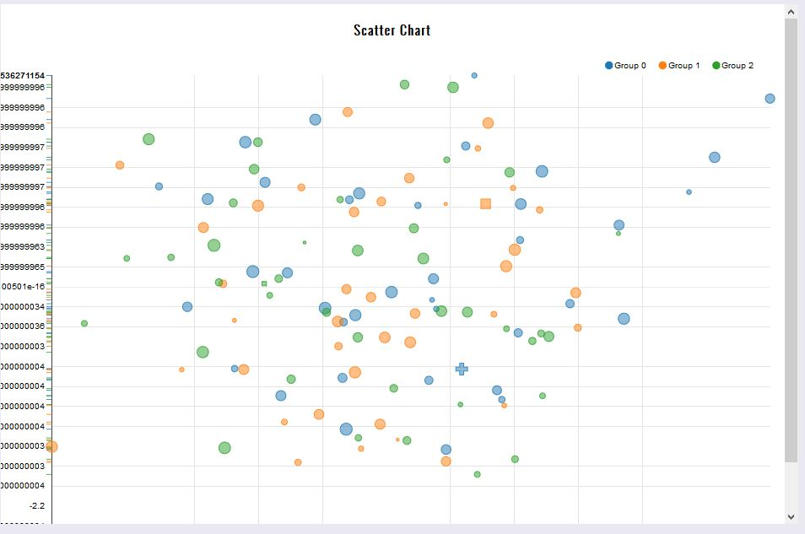
Figure 4 Scatter Chart
<div class="chart_container" id="scatterchart1">

<h3>Scatter Chart</h3>

<svg></svg>

</div>

For the CSV charts we used to write the .js script in the report, In these js script we linked the csv files in the script.

References
Books
http://www.w3schools.com/css/css_text.asp

Good Sample Reports:

http://hplgit.github.io/teamods/writing_reports/_static/sphinx-default/report.html#mathematical-problem

Sample Code:
Search Github code repository for sample codes

